SEPTEMBER 2025 | SOUTH AXHOLME PRACTICE  NEWSLETTER | Issue  #7
Welcome To the 7th Newsletter for South Axholme Practice.
WINTER VACCINES 2025
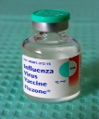
Flu Vaccine

Eligible adults will be able to get their flu vaccination from October 2025. All patients that are eligible will be contacted in due course. The Flu vaccine helps protect against flu which can be a serious or life-threatening illness.


Covid Vaccine
This Photo by Unknown Author is licensed under CC BY
The NHS Covid-19 vaccine is due to be rolled out in October out for those patients who are more likely to become seriously ill. The eligibility has been set slightly differently from previous years and will be available for patients aged 18-64 who are at risk and any patients over 75+. All eligible patients will be contacted when the clinics are available in October 2025.

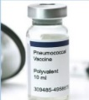
Pneumonia Vaccine
Serious illnesses such as pneumonia and meningitis are helped to be protected with the pneumococcal vaccine. This vaccine is recommended for people at higher risk such as babies and aged 65 and over. The pneumococcal vaccine will be available from September 2025.

Shingles Vaccine
The shingles vaccine is recommended for all adults turning 65, those aged 70 to 79 and those aged 50 and over with a severely weakened immune system. You are more likely to get shingles as you get older or if you have a severely weakened immune system. The Shingles vaccine will be available in surgery from September 2025.
RESPECT FORMS
(Recommended Summary Plan for Emergency Care and Treatment)

It is important that healthcare professionals know how you wish to be treated in an emergency or having life-sustaining treatments which involve risks causing harm, discomfort and loss of dignity, or the risk of dying in hospital when you may have wanted to be at home.

The RESPECT form is a process where you and your healthcare team work out a personalised plan to ensure that you receive the best possible treatment for your individual situation and your wishes are respected.

Your views are crucial, and the healthcare professionals will make every effort to agree a joint plan with yourself. It is important to note that the RESPECT form cannot be used to demand treatments that are unlikely to benefit you and would not be offered. There is a special section on the form to document decisions about cardiopulmonary resuscitation (CPR).

If your condition or circumstances change, or if you change your mind for any reason the RESPECT form can be changed to accommodate your wishes.

Additional information regarding RESPECT forms is available on the practice website or you can click the link below:
RESPECT Forms – South Axholme Practice
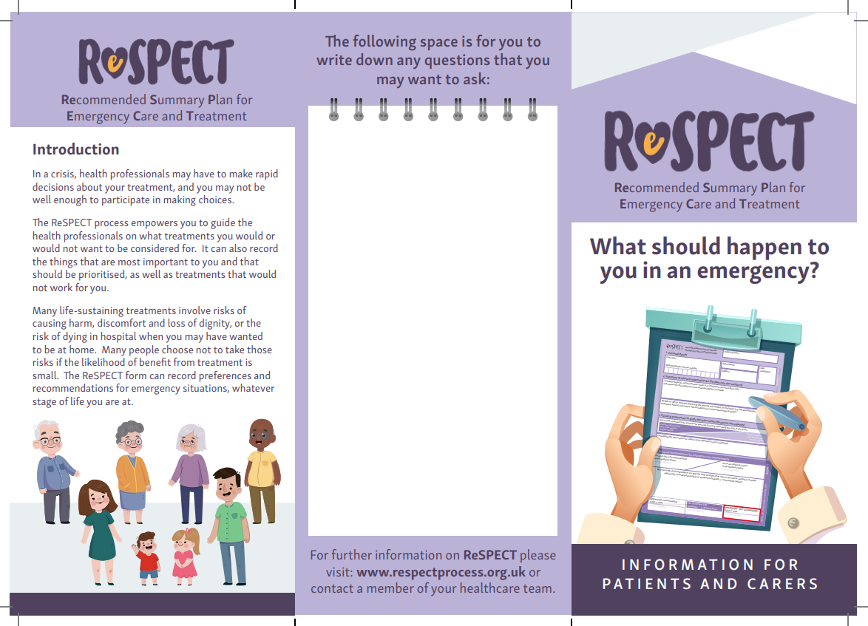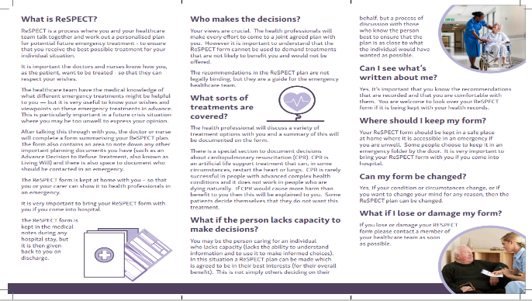

DISPENSARY

Did you know the NHS in Humber and North Yorkshire spends £332 million every year on medicines? A huge £265 million of that goes on repeat prescriptions.
Many people reorder their regular prescriptions every month without checking what they need and then return unwanted medicines to their pharmacy. Unfortunately returned medicines cannot be reused or recycled. They must be destroyed.
This adds up to £26 million of wasted medicines every year – money that your local NHS could use for other vital health services.
How You Can Help
If you get repeat prescriptions (this can also include oral nutritional supplements), take a moment each month to check what you really need. Only order the medicines you’re running out of - By doing this, you’ll not only help save millions for your local NHS, you’ll also:
Stay Well
- Unused medicines can expire and may not work as well as we want them to.
- Keeping big stocks of medicines at home can make drug shortages worse.
Stay Safe
- Large supplies at home can also be dangerous for children and pets if they are accidentally swallowed.
- Medicines are prescribed just for you – sharing them isn’t safe.
Stay Green
- Return unwanted medicines to your pharmacy, not the bin or sink – it’s the safest way to dispose of them and helps the environment.
- Once medicines leave the pharmacy, they can’t be recycled or reused, so only order what you need.
A simple change makes a big difference. Speak to your pharmacy team if you have any questions about how to change your prescription request.
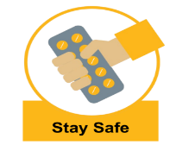
Ordering Repeat Prescriptions from the Practice
The preferred, easiest and most convenient way to order your repeat prescription 24hrs a day is via the NHS App. On the App you can also book and manage appointments, get health information and advice, view your health record securely and view your NHS number.

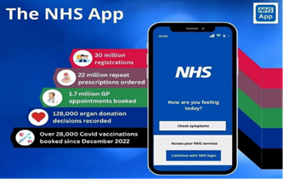

Dispensary Opening Hours

EPWORTH BELTON OWSTON FERRY WEST BUTTERWICK
Monday – Friday Monday – Thursday Monday – Friday Monday, Wednesday & Friday
8:30- 12:30 & 13:30- 18:30 8:30- 12:30 & 13:30- 18:30 8:30- 12:30 8:30- 12:00
Weekends: Closed Friday Weekends: Closed Weekends: Closed
8.30 – 12.30
Weekends: Closed

STAFF UPDATES
South Axholme Practice are pleased to welcome the new Registrars that have joined the surgery. The new doctors will be with the practice between 6 and 12 months.

Dr Olusola Olusanya Dr Titilayo Ajayi Dr Adedapo Ogunjimi Dr Ahmed Abdelrazek


Dr Sarah Assenyi Dr Ahrus Asim

CONTACT DETAILS
Have you recently changed your Address, Phone Number or Email?
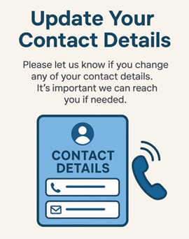
It’s important to let us know if any of your contact details change. Keeping your information up to date means we can:
- Reach you with important updates from the practice about your appointments
- Contact you quickly if we need to discuss your care
- Ensure you don’t miss any vital information
If your details have changed, please speak to reception and let us know at your next visit.

You can now stay up to date with events happening within the practice as we are now on FACEBOOK.  

