March 2024 | SOUTH AXHOLME PRACTICE  NEWSLETTER | Issue  #4
Welcome To the 4th Newsletter for South Axholme Practice.
Pharmacy First
The Pharmacy First service, launched 31 January 2024, enabling community pharmacies to complete episodes of care for 7 common conditions without the need to visit the GP.
Patients will be able to obtain prescription medications directly from a pharmacy, without a GP appointment. It includes the supply of appropriate medicines for 7 common conditions including earache, sore throat, and urinary tract infections, aiming to address health issues before they get worse.
Community pharmacies offer a more convenient way to access healthcare that includes support with healthy eating, exercise, stopping smoking, monitoring your blood pressure, contraception.

Accessing Pharmacy First services
The table below shows the 7 common conditions pharmacists can manage.
Acute otitis media* Sinusitis
Impetigo Sore throat
Infected insect bites Uncomplicated urinary tract infections
Shingles

Measles Outbreak
There has recently been an increase in Measles cases across the Isle.
The Measles rash appears brown or red and blotchy on skin. The rash develops 2 – 4 days after the onset of fever and spreads from the head to the body over the next 3 to 4 days. If you feel yourself or a relative may have the measles infection a telephone consultation can be offered to discuss symptoms. Patients are requested NOT to attend the surgery without prior arrangement with a clinician.

Alternative initial Symptoms include Fever, Conjunctivitis, Cough, Runny nose, sneezing. This may be followed by small grey/white spots on the inside of the mouth 1 – 2 days before rash onset and may last for 2 – 4 days.
Message from Dr Whittaker
I am really sorry for my sudden disappearance from the surgery but unfortunately, I have had to take compassionate leave for the next few months.
I just wanted to explain why for those that have not heard.
In early January, my little seven-year-old girl (Lydia) suffered a cardiac arrest due to an unknown bowel malformation causing bowel obstruction and ischaemia.
Her life was thankfully saved, and she underwent emergency surgery but unfortunately, she has some big hurdles to overcome now due to sustaining a brain injury during the arrest – learning to walk, talk, sit and eat to name a few.
We are currently still living in hospital facilities, but she is doing fantastically.
I appreciate your understanding at this difficult time and will be back in surgery when things have settled back down.
Covid Spring Booster Vaccines
The practice will be commencing the Covid Spring Booster campaign from 22nd April 2024.
All eligible patients will be contacted in due course to book an appointment.
New Patient Registration Forms
New patient registrations are now completed online. Anyone wishing to join the practice can register via our website where they will need to complete the registration form.
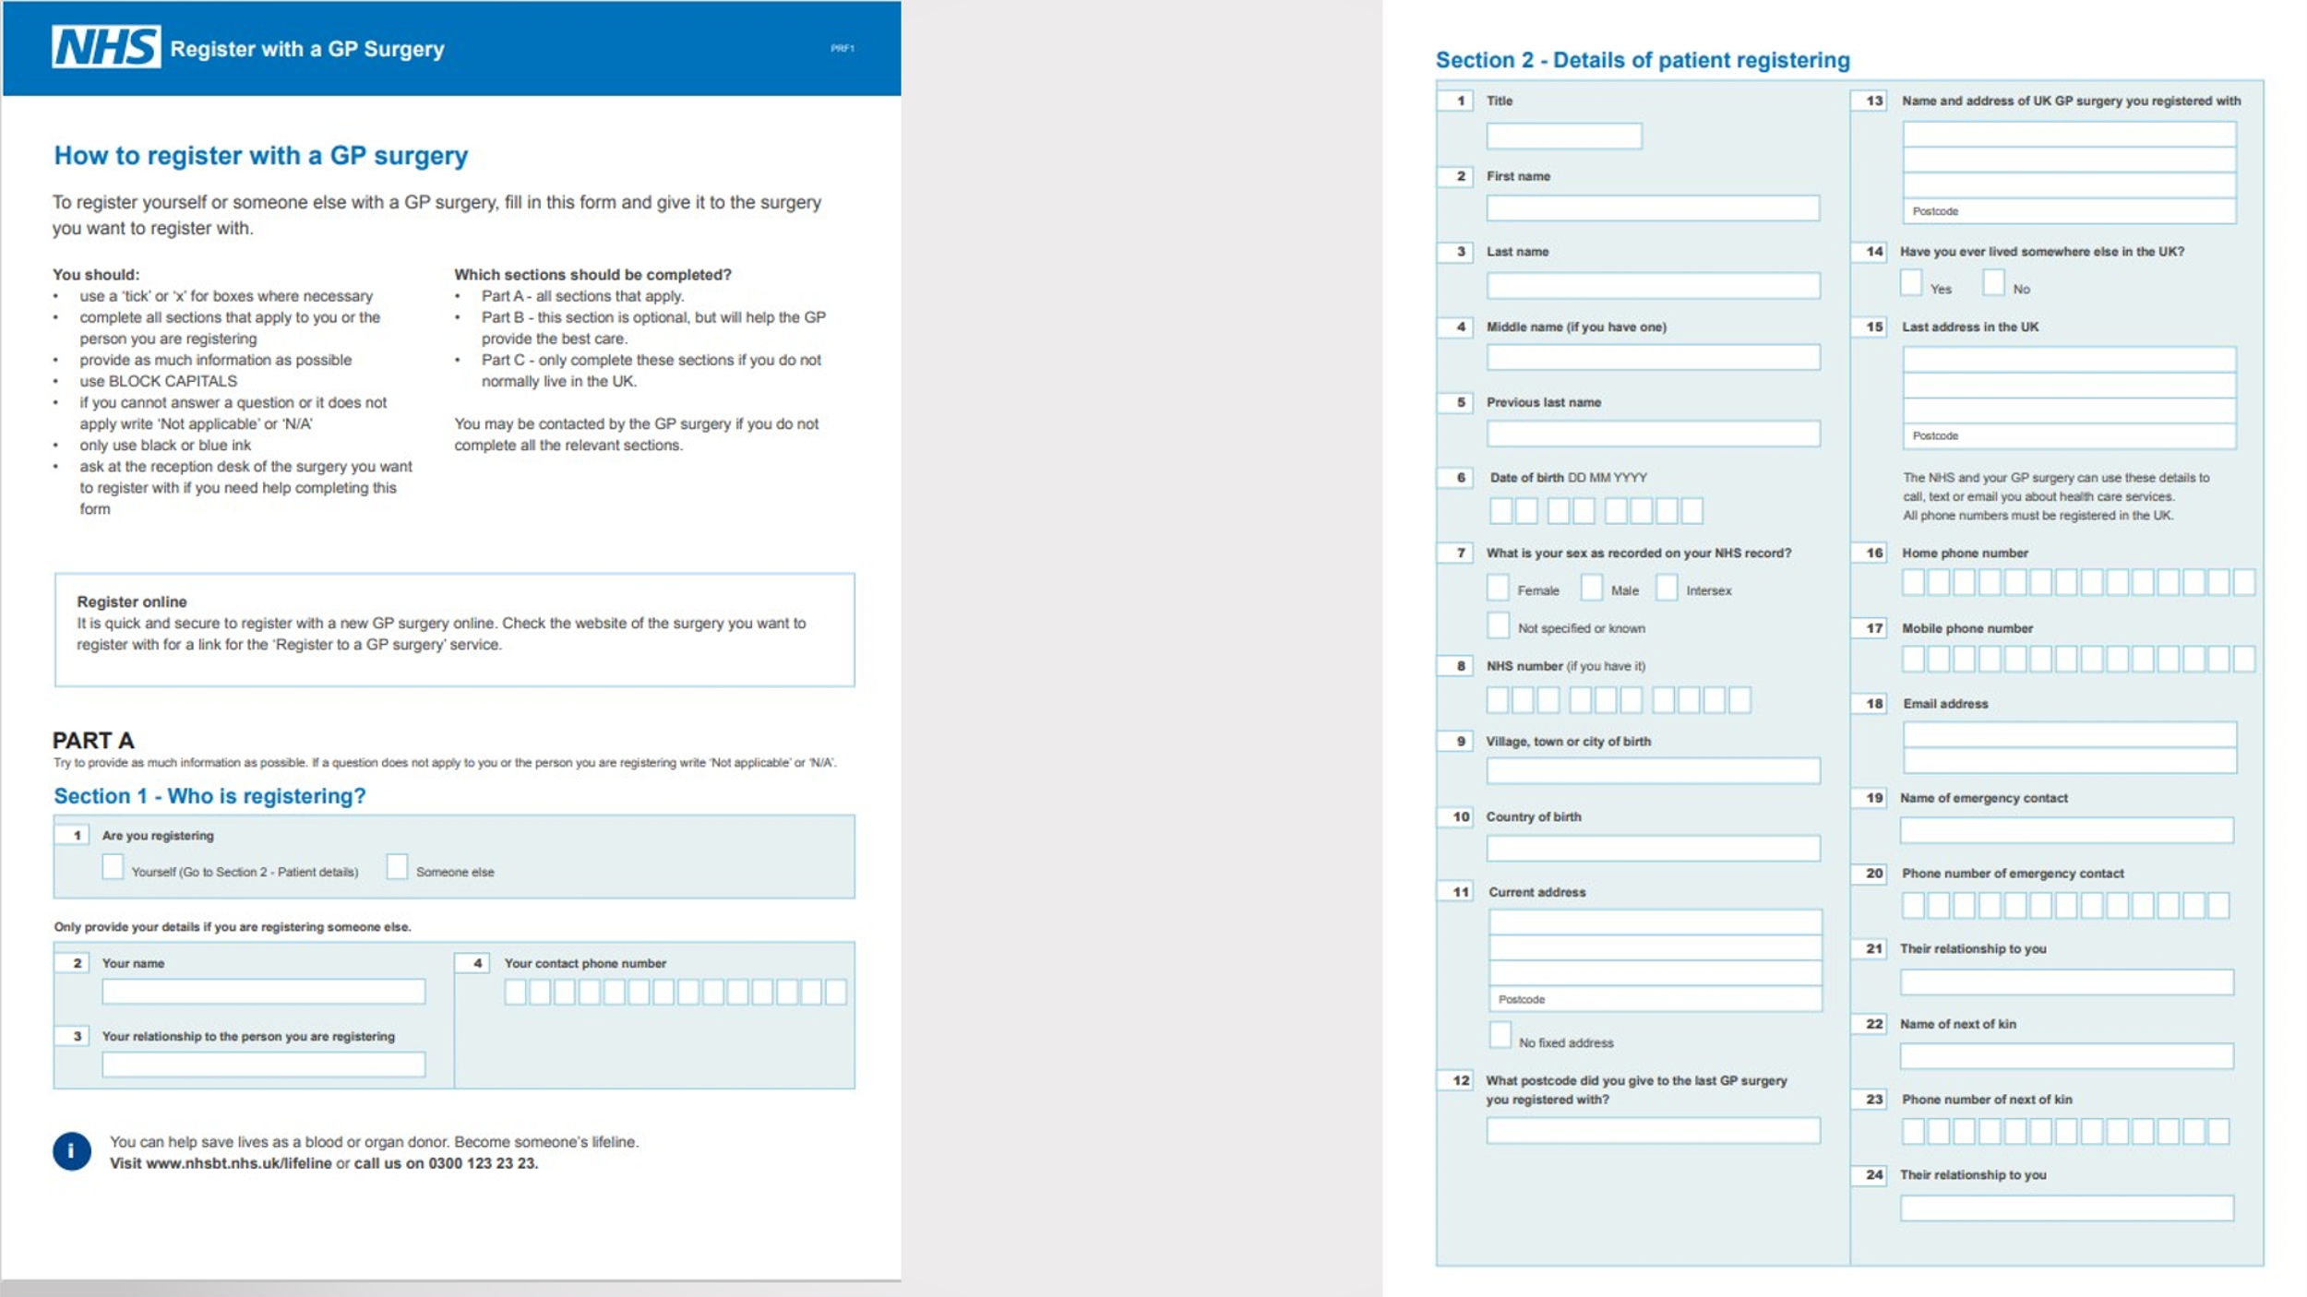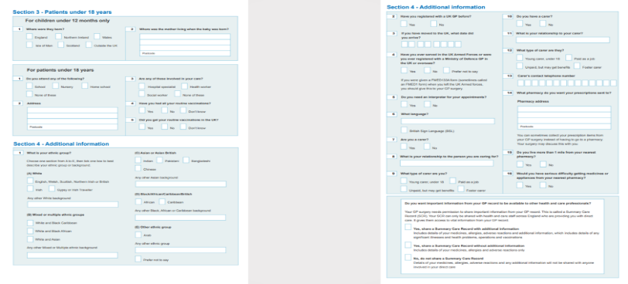
Anyone patients who are unable to register online can register via the QR code in all surgery reception areas or at Epworth Surgery reception desk. Patients no longer need to provide a proof of address or ID for Practice registration. Once registered the patient will receive a text message inviting patients to access the practice online services. ID will be required to set up an online services account. This will also allow you to utilise the NHS App.
Staff Update
Introducing General Practice Assistants
South Axholme Practice are pleased to welcome a new role within the team of General Practice Assistant.
General Practice Assistants work as part of the clinical team to support GP’s & Nurses in routine tasks. By supporting Clinicians with some basic clinical duties, they are also supporting the smooth running of appointments during surgery hours. GP Assistants work with the direction of a GP who has the overall responsibility for your medical care.
Basic clinical duties include – Bloods, Blood pressure checking, ECG’s, Dipstick Urine Testing, discussion of healthy lifestyle choices.
South Axholme Practice are pleased to announce that we are currently training 3 new General Practice Assistants within the surgeries.

South Axholme Practice Dispensary Opening TImes
Monday to Thursday: Monday to Friday:
08:00 – 12.30 – 13.30 – 18:30 8:30- 12:30 and 13:30- 18:30
Friday: Weekends: Closed
08:00 - 12.30 - 13:30 - 18:30
Weekends: Closed
PLEASE NOTE: THE PRACTICE IS CLOSED GOOD FRIDAY AND EASTER MONDAY.
Out of Hours/Extended Access
For advice and urgent medical attention outside our normal surgery hours, please call 111.
Patient Call back service – Queue Buster
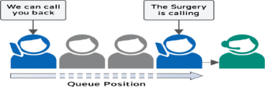
Once our phone system reaches a certain number of patients in the queue, it will give the caller an option to receive a call back, maintaining your position in the queue. The Caller can hang up and the surgery will call you back when you reach the front of the queue. Or alternatively if your problem is non urgent have you tried to contact us via online through our website. This can be used 24 hours a day and contacts are reviewed usually within 48 working hours.

Events Within The Isle
You can now stay up to date with events happening within the practice as we are now on FACEBOOK.

